**Ideation Phase**

**Define the Problem Statements**

|  |  |
| --- | --- |
| Date | 24 January 2024 |
| Team ID | LTVIP2025TMID49157 |
| Project Name | Cosmetic Insights : Navigating Cosmetics Trends and Consumer Insights with Tableau |
| Maximum Marks | 2 Marks |

**Customer Problem Statement :**

**I am...**  
A cosmetics user who deeply cares about my skin health, appearance, and finding the right products that suit my personal needs — whether it's related to skin type (oily, dry, sensitive), lifestyle, or ethical values (like cruelty-free or sustainable products).

**I'm trying to...**  
Discover and choose cosmetic products that are genuinely suited for my specific skin concerns, preferences, and budget, while staying updated on trends and making informed decisions.

**But...**  
I often face confusion and overwhelm due to the abundance of product choices, inconsistent or unclear labeling, and a lack of personalized recommendations that reflect my unique needs.

**Because...**  
Many brands and retailers present generic information, prioritize trends over transparency, and fail to offer user-friendly insights based on real consumer experiences or needs.

**Which makes me...**  
Feel frustrated, uncertain, and hesitant to try new products — leading to poor purchase experiences, wasted money, and dissatisfaction with my cosmetic journey.

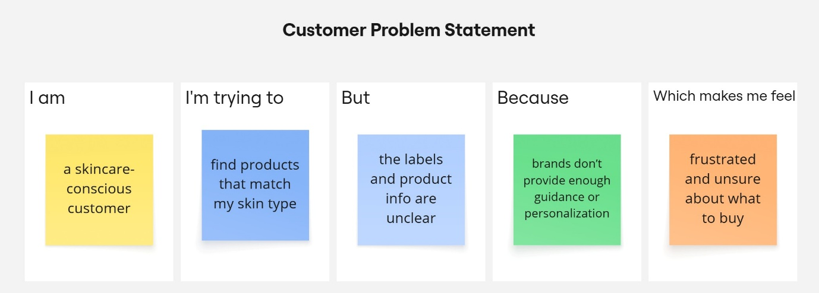

|  |  |  |  |  |  |
| --- | --- | --- | --- | --- | --- |
| **Problem Statement (PS)** | **I am (Customer)** | **I’m trying to** | **But** | **Because** | **Which makes me feel** |
| PS-1 | a customer with dry skin | find hydrating products that prevent flakiness | most products don’t last or worsen dryness | they lack proper moisturizing ingredients | disappointed and reluctant to try new items |
| PS-2 | a customer with sensitive skin | find cosmetics that don’t irritate my skin | many products cause redness or itching | brands don’t clearly list potential irritants | worried and unsafe using new products |